My Experience in Creating StudyTimer
When the idea of code literacy was first introduced in our lectures, I was able to understand it on an intellectual level. However, it was not until the completion of the StudyTimer application that I fully immersed myself into the concept of thinking computationally. My application started as an attempt to help with my own problem of not staying focused while studying, but it turned into something much more profound.
What Drove My Need to Create It?
As someone who has always found it difficult to focus on their studies, it seemed ironic that this was precisely the area of knowledge that I was trying to acquire as a student of computational systems—I, of all individuals, could not seem to efficiently allocate resources on how to take best advantage of mine. The lightbulb moment occurred during a particularly distracting study session. The question that occurred was this: What if I created something that catered not to how I was SUPPOSED to study, but how exactly I do?
This aspect of humanity was what acted as the motivation behind my project. I was reminded of the concept of low floors, high ceilings by Resnick et al. (2009) in our readings because I felt the desire to do something introductory, and I could elaborate on this concept with more knowledge of coding.
This directly illustrated Still, & Crane (2017) concept of the system image gap outlining the disconnect between my mental model of how the timer should work and the user's actual understanding, and to bridge this I needed to apply the user-centered design principles.
Where Theory Met Practice
My first concept map was more of a technical specification diagram. All arrows led from Python libraries and functions. However, after discussing it with fellow students in the tutorial sessions, I was forced to consider the human aspect. A classmate asked, "How will you feel when the timer sounds? Will it be an interrupt or relief?" This question completely turned the design on its head.
However, I began looking upon the project not merely as a timer but as an ongoing dialog process from me to the computer. While implementing the design with Tkinter, I first created something that was perfectly intuitive in my own mind but puzzling to every tester that I handed it to. The naming of the push buttons was misleading, the progress bar was not animating nicely, and the notifications seemed more like annoyances than useful functions. I had fallen into the pitfall which Rushkoff (2010) cautions us about in our readings on coding: coding the computer to think like me.
The Evolution: From Functional to Meaningful
When the simple timer started operating, I started to question the information which was being captured. All the sessions of testing provided information about focus patterns, break patterns and productivity patterns. It was here that the project transformed into something better than a utility.
The Matplotlib implementation of the visualization dashboard was like having a mirror to myself to learn about my learning habits. I learned that I was most effective when working in late morning shifts and I worked better when having slightly more breaks between some subjects. This data-based self-awareness was the same as the principles of Cairo (2012) regarding functional art the visualizations were not merely beautiful but also informative.
The customization tools were an extension of the understanding that in each and every day there was a new need where my research study can be useful. Days would come when I would be able to focus on a long duration of time and then there are days that I would rather have more breaks. The development of the settings window taught me a great deal regarding the optimization of flexibility with common sense.
Concepts
The most pertinent link was discovered in the realization of the replication of exactly what Papert (1980) outlined in regard to constructionist learning. What was happening was more than the creation of a timer. What was occurring was the building of an understanding. Each problem, from sound processing to data saving, was an experience of reconstructing current knowledge. Below is part of the code showing timer creation.
# Event-driven architecture
def update_timer(self):
if self.timer.is_running:
still_running = self.timer.update()

if not still_running:
# Session ended naturally
session_info = self.timer.get_session_info()

# Log completed session
if self.timer.current_session == "work":
duration = self.timer.work_duration // 60
self.session_manager.save_session("focus", duration, completed=True)
else:
break_type = "short_break" if self.timer.current_session == "short_break" else "long_break"
duration = (self.timer.short_break_duration if break_type == "short_break"
else self.timer.long_break_duration) // 60
self.session_manager.save_session(break_type, duration, completed=True)

self.play_sound()
messagebox.showinfo("Session Complete!",
f"{session_info['name']} finished!\n"
f"Ready for {session_info['next_session']}?")

self.update_display()
self.root.after(1000, self.update_timer) # Update every second

The peer feedback sessions were invaluable. For instance, when one of the testers asked for the inclusion of session notes, I was averse to it—to me, it seemed unnecessary. However, later on, our discussion on extensible design helped me realize that often the best designs tend to extend beyond their intended use. Learning how to incorporate this feature taught me more than a tutorial ever could.
Reflections and Realizations
Turning backwards through the project log, it seems that I can track the development of my thoughts. "How do I create a countdown timer? Why doesn't this button function?" The earlier log postings center upon technical issues. The later ones revolve more around more intellectual issues. "How can a smoother transition from one session to another be achieved? " "What is the most effective methodology for progress indication which doesn’t result in anxiety? " This evolution from technical to conceptual questions reflects Resnick et al.'s (2009) 'high ceilings' concept thinking more about the user experience and emotional impact rather than just functional requirements.
This indicates that I have developed a higher level of code literacy. Although I began to view coding as typing in the correct syntax, it is becoming more and more an act of communication. This may be with the computer with the users of the code in future or with me. Following rules as a form of coding has ceased being a matter of rule following and has become a part of coding culture.
Moving Forward: Code Literacy
The project has modified my relationship with technology. In place of a completed product, an application, what I would have thought of is now a conversation. Something that I might have previously found as a cause of anxiety and a subject of programming is now astounding me with the wonder of what will be found. The StudyTimer currently sits on my computer desk, and is counting down time to each study period, but it is the skills of computational thinking that I have acquired in its creation that is actually of use to me.

References
Cairo, A. (2012). The functional art: An introduction to information graphics and visualization. New Riders.
Papert, S. (1980). Mindstorms: Children, computers, and powerful ideas. Basic Books.
Resnick, M., Maloney, J., Monroy-Hernández, A., Rusk, N., Eastmond, E., Brennan, K., Millner, A., Rosenbaum, E., Silver, J., Silverman, B., & Kafai, Y. (2009). Scratch: Programming for all. Communications of the ACM, 52(11), 60–67. https://doi.org/10.1145/1592761.1592779
Rushkoff, D. (2010). Program or be programmed: Ten commands for a digital age. OR Books.
Wing, J. M. (2006). Computational thinking. Communications of the ACM, 49(3), 33–35. https://doi.org/10.1145/1118178.1118215
Still, B., & Crane, K. (2017). Fundamentals of user-centered design: A practical approach. CRC press.
Start Concept map
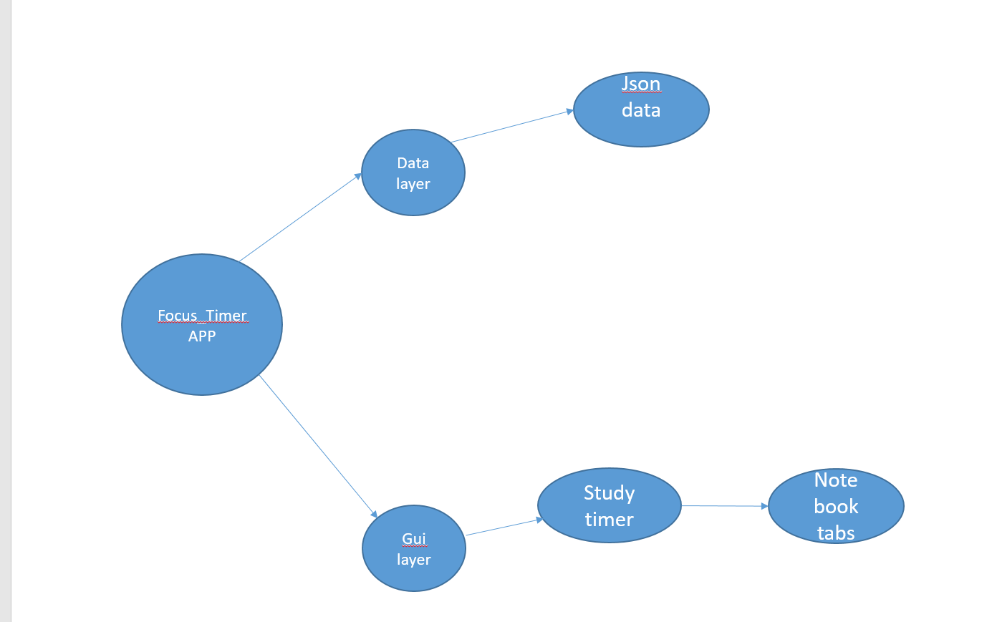

Concept map after project
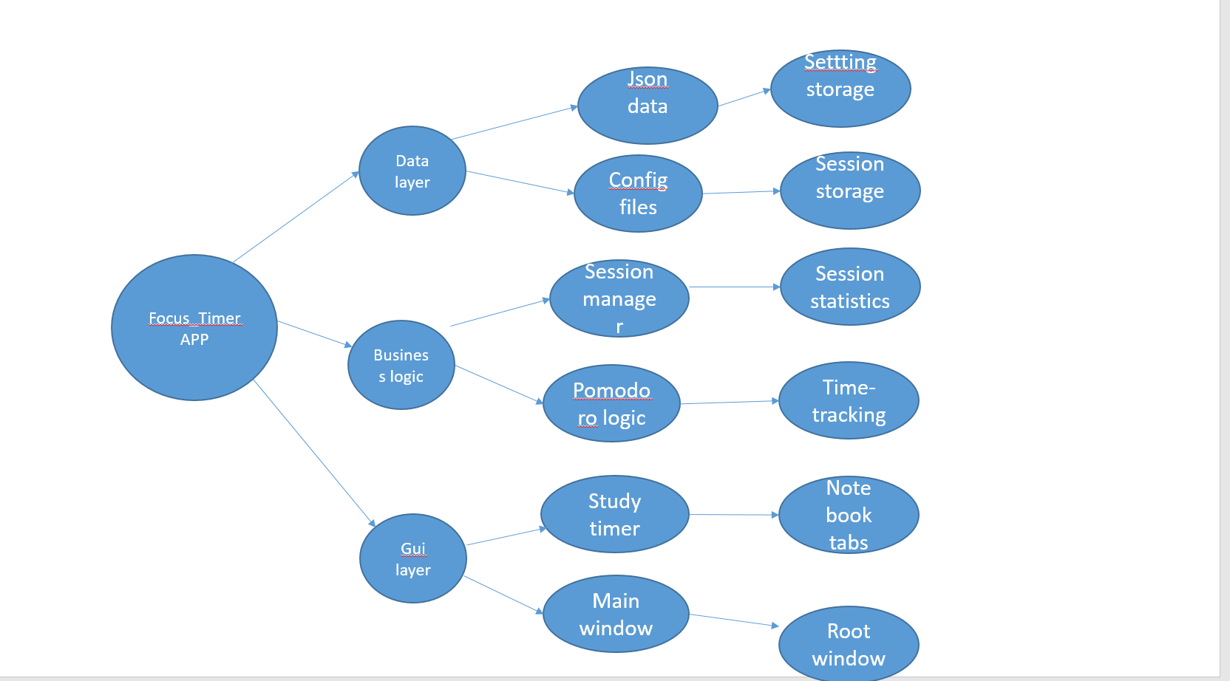

- Review
Reviewer Name: _______________________________________________
Project Creator: ________________________________________________
Project Creator Email: ___________________________________________
Date: ________________________________________________________
Project: ______________Study_time________________________________________

1. What Do You Like About This Project? Have the creator execute (run) their project, so you can see it in action. If it’s interactive, play with it yourself. (The creator is to provide only minimal instruction so you can use it independently).
Focus on what’s interesting, fun, or engaging.
- What part of the project so far stood out to you or made you smile?
- What felt especially creative or original?
- If you needed some instructions on how to use it, remind the creator to include these in the README.md file in their repository (if they haven’t already).
What stood out most to me was how interactive and dynamic the project feels. The pages are easy to navigate from one section to another and the readme file guides everything
2. What Is the Project Trying to Say or Do?
Think about the message, feeling, or story behind the project.
- What do you think the creator wanted to express with this project?
- In your own words, what does the project do?
The project is about scheduling study time among students for efficient preparation

3. How Well Does It Work?
Look at both the idea and the current prototype.
- Is there something in the project that worked really well or surprised you? The tune and the melody and the instrument use
- Is there anything that didn’t work or seemed confusing?
The prototype works quite well overall.
What worked well: Navigation across the pages
What could be improved: It would help to make the interface or code structure more intuitive — for example, clearer section labels or more bigger fields for entry of data

4. Git Repository?
Access the Creator’s Git Repository using the link they have provided.
- Does the repository link work, and can you access the README.md and project files?
- How well has the repository been documented via the README.md?
- Does it provide details of the project and how to run the code?
- If the README.md includes URL’s, do they work correctly? If there are additional opportunities for improving the README.md, offer your suggestions.
- Does the repository include all source code and project files (such as external code libraries, assets such as images, sounds etc.)?
- Is the structure of the repository clear and logical and use folders (i.e. directories) to assist with navigating different areas of the repository (especially for large projects).
- Does the repository include extra materials to further demonstrate the project? While an option for all projects, this is important for physical computing projects, where additional, images and/or videos of the project can be included.
Yes, the repository link works properly, and I was able to access both the README.md file and all associated project files without issue. The repository is organized clearly, with logical folders separating code, assets, and documentation.
The README.md provides a solid overview of the project and explains how to run the code, but it could benefit from more detailed, step-by-step instructions for setting up dependencies and modifying music settings. All URLs and links included in the file function correctly.
The repository includes all necessary source files and external assets (such as sound files and libraries), making it easy to reproduce the project. To improve documentation, I would suggest adding:
- A short setup guide with installation and usage examples.
Overall, the repository is well-structured and functional, with only minor improvements needed for usability and clarity.

5. How Clear is the Code?
Quickly look at the creator’s code file(s) in the repository.
- How easy or difficult is the code to read? Has it been broken into small logical “chunks”? Does it need more spacing between different blocks of code to make it clearer?
- How much sense do the names for variables, functions etc. make in relation to what they do?
- How much has it been commented? Are more comments needed?
- How clear are the comments at explaining the code?
Variable and function names are mostly clear but if you could adjust on user interface especially on adding more colors to make the app more appealing it could have been better
Overall, the logic is solid and modular enough to follow, but readability improvements would make it even stronger.

6. How Clear is the Creator’s Explanation of the Core Innovation or Functionality?
Now have the creator explain the core functionality or key innovations and the code behind it.
- How clearly did they explain their code and how it works? Were they able to use key coding concepts?
- How deeply did they explain their code? What improvements could they make to better demonstrate their understanding?
The creator explained the core functionality clearly
To further strengthen this section, they could explain the technical reasoning behind certain choices — such as why specific algorithms or sound libraries were used. This would show a deeper understanding of both creative and computational aspects of the project.

7. Ask a Thoughtful Question
Help your classmate think more about their creative or coding process.
- What question can you ask that gets them thinking about how or why they made something?
Have you considered integrating real-time user input
8. Final Thoughts
Share your overall experience with the project.
- In one or two sentences, how would you describe the project and your reaction to it?
Overall, Study timer is a creative and impressive project that can help the student learn more. With a bit more polish in documentation and code structure, it could easily become an inspiring example of generative art in motion.
*Remember to document your progress, thoughts, reflections and so in in your journal!

- Project journal
When I began to create the StudyTimer, I envisioned it as a mere project to assist me in focusing on studying. I used to get distracted a lot, and I needed something that would help me maintain some form of consistency. Initially, it was really a simple concept, a timer that counts down and beeps in case the time is up. However, as I started creating it, I noticed that I was not only learning how to write a program and have it run, but also how to think, ponder, and write using code.
During the initial phases, I was entirely focused on the technical perspective. I desired the smooth operation of the timer, proper functioning of the buttons, and an appealing interface. I wasted hours debugging the reasons why the progress bar was not progressing or the reasons why the labels were not displaying correctly. Each tiny bug was a defeat, and, with time, I began to see them differently. I started to view error messages as a way of guidance instead of failure. Each bug taught me something about the computer misunderstanding my logic, and each fix provided me with confidence. By the time I was able to bring the after method under a smoothly and fluidly running procedure, it was like a breakthrough in my head- it was as though I had mastered the language of the computer a syllable more.
One of the most important aspects of the project was peer feedback that was provided in the project. During one of the review sessions, a classmate of mine came up with an idea that I needed to create a place in which the user could leave short notes after each study session. I, initially, denied the idea because I did not feel the need. I had only an interest in keeping time, and not thoughts. But, thinking more about it, I had seen the worth there could be in such a triviality. It helped the timer to go beyond being a tool- it became a friend, one to be thought of. The inclusion of the notes section was a more human and interactive way to make the app, and the process made me realize how crucial collaboration is in the design. Peer review has taught me that feedback is not to be viewed as a critique, but as a chance to build upon an original idea and improve it.
I continued to optimize the project, and as I did so, I realized just how much my thinking had changed. My previous entries in the project log were strictly technical, such as how to fix, position, or attach some features. My thoughts later became conceptual. I started posing such questions: What does the timer do to make a user feel? Is it inspiring or pressurizing? What can I do to make the transitions between sessions seem natural? The change made it clear to me that I was no longer writing code; I was creating an experience.
StudyTimer was no longer a productivity tool by the time the project was completed. The graphics of my data of interest made me realize some trends in studying and working hours. When I saw those graphs, I felt as though I had been looking at a mirror that was showing me my learning patterns. The whole process of coding, debugging, testing, and feedback allowed me to develop in a better way than I previously thought. I would now consider programming not only as a technical process, but as a creative and reflective one. The StudyTimer is still helpful in my studying, yet, more importantly, it symbolizes the way I have acquired greater knowledge about patience, design, and collaboration in the process of creating it.

- Code snippets
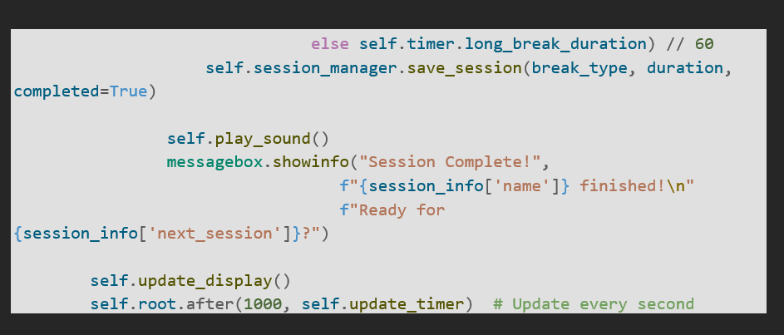
Here, the break type (short or long) is verified and completed session is saved by the save session code. Then it gives a sound and displays a pop-up message that the user is over with the session and that he/she is going to start another. Lastly, it will refresh the display and start self.root.after(1000, self.update_timer) to update the timer every 1000ms or one second of time so that the countdown would run flawlessly in real time.

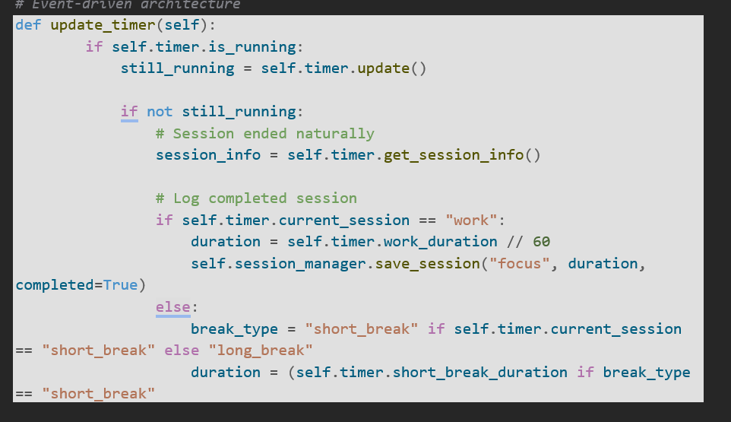
This code specifies the update timer function, which controls the running of the timer and which keeps a record of the completed sessions. It initially verifies whether the timer is still running otherwise, there is an indication that a session has been terminated. The code then recalls the information on the completed session and records it - whether it is a focus session or a break (short or long) and the duration. In essence, it maintains the timer on track and logs every work or break session done automatically.

